**AUTISM ASPERGERS FRIENDSHIP SOCIETY**



**WEBSITE USABILITY REPORT**

**AAFSCALGARY.COM**

December 5, 2014

University of Calgary

COMS 363 L-02

# Executive Summary

**The Autism Asperger’s Friendship Society of Calgary (AAFS)** is an organization for people on the Autism Spectrum and their loved ones. The AAFS provides a community for supporters to run workshops, seminars and group activities and initiatives to better themselves. Their website is a portal for members and the community to coordinate and promote a majority of their events. In order for it to be an effective tool, the AAFS website must be easy to navigate, well organized, and engaging. Our usability study conducted on the AAFS website researched the community’s reaction to the website’s accessibility, design, identity and navigability. This report includes the research conducted, its findings, and our recommendations for improvement.

The guidelines our group used for the study were selected from contemporary literature and published research literature. Through our research, we noted four prominent fields for an effective website, these fields became our evaluation criteria that we evaluated the AAFS website on. These criteria are:

* Accessibility
* Design
* Identity
* Navigation

Our primary research method was an anonymous usability survey administered via eSurv to students at the University of Calgary.

Survey questions were created based on the aforementioned usability criteria and the results were tabulated and included in this report. A total of 14 responses were received. The survey results were able to identify certain areas of negative user feedback. Example Text: Overall, respondents disliked the amount of headings and links in the navigation menu, the clarity of content on the homepage, and the aesthetic design of the website.

Our recommendations to improve the usability of the AAFS website are as follows:

1. Combine similar headings in the navigation menu
2. Use a monochromatic colour scheme
3. Use high-quality graphics
4. Fix clarity of content on the homepage

By following our recommendations, AAFS’ will provide a higher quality user experience through the improved accessibility, design, identity, and navigation of their website.

Table of Contents

Executive Summary 1

List of Figures 2

Introduction 4

Purpose 4

Background 4

Rationale 5

Objectives 5

Scope 5

Research Methods 5

Research Criteria 6

Primary Research 7

Secondary Research 7

Ethical Considerations 7

Results and Discussions 8

Accessibility 9

Design 9

Identity 11

Navigation 11

Conclusion 12

Recommendations 12

Major Recommendations 12

Minor Recommendations 12

References 12

Appendices 14

Appendix A: Survey Ethic Foreword 14

Appendix B: Survey Questions 15

Appendix B: Survey Questions cont… 16

Appendix C: Survey Results 17

Appendix D: W3C Accessibility Guidelines 18

# 

List of Figure

# Introduction

## Purpose

The purpose and scope of this report is to present an inclusive review of our group’s research into AAFS’ website usability and it will recommend the necessary improvements according to our research. Our research of the website’s usability included reviewing contemporary usability practices and methods as well as collecting website specific data from our usability survey. Our evaluation and recommendations for the website are based on the 4 core components:

* Design: how effectively the user interface helps the user;
* Identity: marketing, authenticity, and user account accessibility;
* Accessibility: how easy is it to gain information from the website;
* Navigation: how easy is it to get around the website.

Through the evaluation of these criteria, our survey has determined areas of negative and positive response from users. By following the recommendations in this report, it will offer AAFS a chance to improve their user’s experience in an effective manner.

## Background

AAFS is a non-profit organization that provides respite care in a recreational environment for all individuals on the Autism spectrum. Since 2004, the AAFS has worked to facilitate recreational programs and activities to help their members develop social, life, and communication skills by providing them with the opportunity to practice these skills in a safe community (AAFS Calgary, 2014). Because this is word for word, shouldn’t it be in quotation marks? Otherwise we should paraphrase this to: The Autism Asperger’s Friendship Society of Calgary (2014) is a non-profit organization that provides care for all individuals on the Autism spectrum by facilitating recreational programs and activities that help their members develop social, life, and communication skills within a safe community. Idk though,

To exemplify this, their mission statement was written by two members of AAFS on their website:

**The Autism Asperger’s Friendship Society’s Mission Statement**

*Friendship means someone who you can trust and/or someone who heals you. You cannot simply ask to be Friends, or if the other person is your Friend, it is much more advanced than a yes or no answer, and Friendship builds up over time.*

*Friendship is "People getting to know other people and being interested in one another.  Liking them for who they are, and not judging them.  Not judging the book by its cover. (AAFS Calgary, 2014).*

## Rationale

As an organization that focuses on providing a community that facilitates the development of personal and interpersonal skills, the website has a requirement to also facilitate this development. This usability study is meant to research the website’s ability to support their online community, and in the areas that it is not, provide constructive feedback that encourages improvement in usability. As a non-profit organization, AAFS is also heavily reliant on either its members or the general public to cover expenses. By having a professional, user-based website for AAFS, potential investors will have an easier time connecting to their PayPal account.

## Objectives

* Determine areas of positive and negative user experiences through our usability survey, and whether they ease or impede a user’s ability to use the website effectively;
* Address these areas and produce possible low cost, high reward solutions that are supported by published literature and articles;
* Provide AAFS with viable recommendations that will improve their website usability with reference to both our primary and secondary research.

## Scope

The usability study focused on 4 main areas of website usability: design, identity, accessibility, and navigation. These 4 features are vital in a website because they help determine how easily users can obtain access to the information they are seeking, as well as the user’s overall impression of the website. Improvements to these areas will effectively enhance the user experience of the AAFS website.

# Research Methods

Our AAFS website usability study was produced by means of primary and secondary research. In order to determine areas of positive and negative user experience, we formulated primary data through the use of an online survey. To create the appropriate usability metrics for our survey, we consulted secondary research sources that would provide insight into effective web design. Our secondary research consisted of a mix of detailed peer-reviewed literature that studied particular facets of web design, and non-peer reviewed articles that focus on contemporary design methods and specialty sources for AAFS specific requirements. It is with this research we were able to determine the areas of AAFS’ website that enhanced and detracted from the website’s usability.

### Design

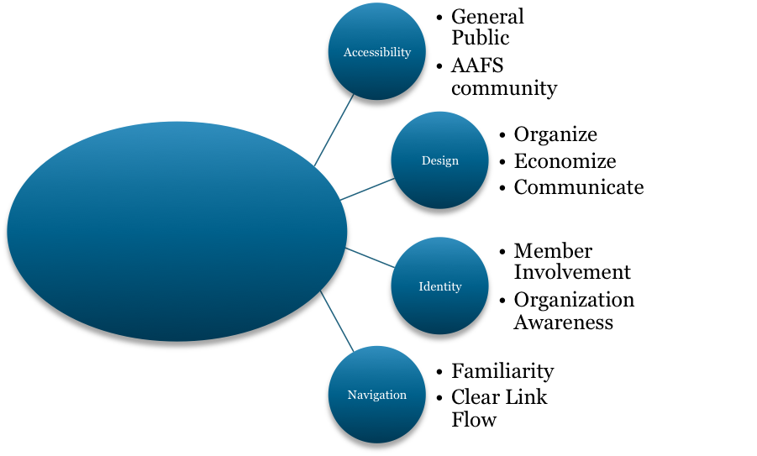

Our design evaluation draws heavily from Martin (2014) and the importance she places on “Visual Language” and three principles of user interface design, Organize, Economize, and Communicate. From Martin (2014), we can conclude that the design of a site can be closely tied with our other criterion, but special consideration should be taken to manage the overall aesthetics to enhance the user experience. We will go into detail on the aesthetic effects on usability in the results and discussion section.

### Navigation

As described by Blackmon et al (2005), there are specific problems associated with Navigation and there is work being done to automate and quantify the effects of these problems. Problems mentioned by Blackmon et al (2005) we felt may affect AAFS’ website particularly were Weak Link, Unfamiliarity, Competing Headings and Competing Link problems. These will be covered in detail in our discussion of how to improve AAFS’ navigation.

### Accessibility

Information and communications has been established by the UN as a basic human right (*Convention on the Rights of Persons with Disabilities and Optional Protocol*, 2006) from proposal references. Thus, our criteria will be based on the standards set out by the UN and the World Wide Web Consortium (W3C). In the W3C’s preliminary review standards (2014), they cover a large number of issues and solutions to web accessibility in relation to those who may have disabilities and for simplification of website accessibility in general. Areas such as the website’s accessibility functionality and how well it generally follows the guidelines set out by the W3C will be the focus of this section in our Results and Discussion section. A simplified list of their suggested guidelines has been added to this report for convenience as Appendix D.

### Identity

The use of the internet for AAFS to brand themselves is not limited to their own members, but is often used to promote their events. Creating an attractive website and branding on their website will make it easier for their extended customer base to know that they’re at a AAFS event specifically. As outlined by Kianga et al. (2000), marketing can be broken down into 3 distinct channels: communication, transaction, and distribution. Our identity criterion will focus mainly on communication and transaction and communication as AAFS does not sell a material good under most circumstances (distribution). The communication channel deals with the AAFS website’s ability to collect, organize and relay information about its audience, and the interaction between AAFS services and its ‘customers’. The transaction channel is involved with increasing the AAFS membership, as well as their local and global visibility (promotion and branding) (Kianga et al, 2000).

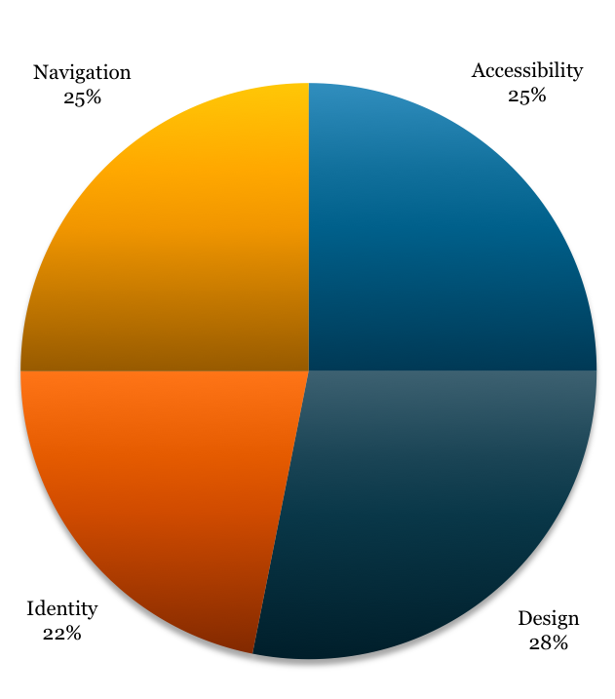

## Secondary Research

Secondary Research was a continual process from the creation of our research criteria to finalizing our recommendations for AAFS. Whereas scholarly articles were the basis for determining the research criteria, we based our recommendations on a variety of online publications. These sources, while still relating to our criteria, were both peer and non-peer reviewed. They were included based upon their contributions to either general web design practices or those specialized in website usability considerations for those on the Autism Spectrum. This research was then used to examine the primary data and determine usability chokeholds and provide recommendations based on feasible solutions.

## Ethical Considerations

Our survey was in prepared and administered in compliance with the University of Calgary Ethics Requirements in order to maintain the integrity of the data, and to protect the identities of our participants. The collected data was gathered voluntarily and anonymously from the participants by eSurv, an online survey service. An introduction and description of how the responses would be used was included with the survey as seen in Appendix B in order to establish transparency with our participants. To read more about eSurv’s privacy policy please refer to their website for more information. A copy of the aforementioned introduction, survey questions and its results will be stored electronically by a member of our group and eSurv for a period of two years in the event that there are questions regarding our research methods or ethical actions.

# Results and Discussions

So what did our participants think of AAFS’ website? In this section we will delve into our survey’s results and what they mean for AAFS’ website. This section has been divided to provide a clear overview of the website’s strengths and weaknesses in each criterion. To determine a general consensus of our participants we scaled their responses of 1-5 (5 being strongly agree), to reflect a 0-100 % agreement of our questions. As seen in figure 3, the results of this calculation determined that design was the weakest part of the website at 44.04% positive user response with navigation scoring the best average user response at merely 61.4%. These numbers do not show a strong positive user experience. A question may be referenced in more than one section as the questions frequently relate to multiple criteria. This is done once again to reinforce that cohesion of all the elements is necessary to create an effective website. Our survey results, formulae and calculations have been included in this report in Appendix C for reference.

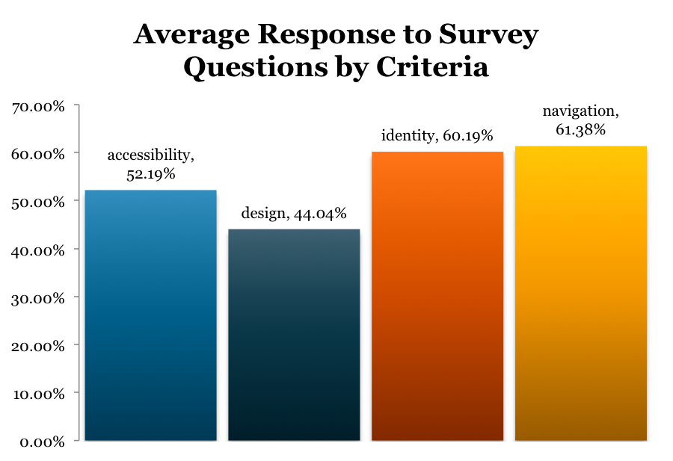

## Accessibility

### General Website Accessibility Guidelines

### AAFS Specialized Accessibility

W3C (2005), states that “it is essential that the Web be accessible in order to provide equal access and equal opportunity to people with disabilities.” As the AAFS Calgary website is dedicated to members of the Autism and Asperger’s community, it is important that information on their website is accessible for those with special needs on the autism spectrum. One aspect of accessibility is readability. Of our participants, 6 out of 14 (42%), felt that the font used on the AAFS Calgary website was adequate and appropriate for users who are on the autism spectrum. Comic Sans (fig. 1) and Arial (fig.2) were two of the fonts that are used on the front page of the AAFS website and because our survey results indicate the choice of font used favorable, we believe it is not a major area of concern.

## 

## Design

An organization's website is a reflection of the organization itself. Having a poor design can negatively impact a user's opinion of the organization and may be the deciding factor in whether or not a user stays on the website. It is therefore in the best interest of the organization to ensure that it has an effective web design. According to Martin (n.d) there are three fundamental principles involved in creating an effective design: Organize, Economize, and Communicate. The first principle, organize, is to provide a conceptual structure of the website; the second, economize, is to maintain simplicity without sacrificing content; and the last, communicate, is to ensure that content is communicable towards the target audience.

It is important to remember that 'effective design' is a relative term, and what constitutes a good design for one organization, may not be good for another. The target audience of this website is aimed at persons with Autism Spectrum Disorder and Aspergers and their families, and consequently the needs of these users must be kept in mind. User-Centered Design (UCD) is one of the most common methods used to ensure usability whilst addressing the needs of the users by determining what functionality the user wants and how it will be used (Lynch & Horton, 2005). As our primary research was not targeted specifically at those with Autism or Aspergers, our secondary research was used to connect our primary research on aspects of design as they pertain to persons with Autism and Aspergers.

From our primary research, nine survey questions were chosen to evaluate the design of the AAFS website. These questions focused on colour scheme, organizational layout, graphics, typography, and visual appeal. As seen in Figure 2, the participants' responses highlighted the need for a better design as most areas received a poor rating. The key areas of concern were found to be the site's colour scheme, the graphics, and visual appeal; with visual appeal receiving a rating of 33.9% approval. There was less of a consensus on the effectiveness of the organizational layout between participants whilst the typography received generally positive feedback.

### Colour Scheme

Question 3.2 from our survey was designed to assess the visual appeal of the current colour scheme of the AAFS website. This question received a rating of 37.5% making it one of the lowest ratings in our survey. According to Colorcom (2010), a colour consultation firm, people make a subconscious judgement of a person, environment, or product within 90 seconds and between 62% and 90% of that is based on colour alone. The current colour scheme of the website is inconsistent across different pages making the website appear unprofessional and haphazard. Additionally, too many colours are used within singular pages making it hard to quickly scan for pertinent and important information. Considering the target audience, care should be taken when deciding a new colour scheme as persons with Autism and Aspergers prefer 'low arousal' environments, as they tend to have heightened sensory awareness (Autism.org.uk, 2014). With this in mind, it is still possible to design a better colour scheme, which will enhance the attractiveness of the site whilst still providing a comfortable environment for its users.

### Graphics

Questions 3.5 and 3.6 of our survey questioned the participants on their opinion of the site's graphics in terms of their visual appeal and whether or not the graphics helped enhance the information provided. The participants responded with little favour towards the graphics with ratings respectively, 37.5% and 33.9%, making it the category with the lowest combined ratings next to the overall visual appeal of the site. This most likely stems from the discordant nature of the header image. The logo is tacked on and appears to float over the rest of the image, while the image itself fails to identify itself with the AAFS.

According to Lynch and Horton (2005), “the header graphics and text are probably the most important elements in making a collection of web pages feel like an identifiable “site” rather than a random assemblage of files.” Through the use of more consistent graphics and an improved header image, the AAFS can improve its aesthetic design.

### Layout

Three questions from our survey, 2.2, 2.9 and 4, asked participants to rate the website's organizational layout in terms of user friendliness and organizational content. The responses were respectively, 53.6%, 50% and 50%, making the results relatively inconclusive. Despite the lack of consensus, these values suggest that there is room for improvement to help ensure greater usability. A consistent design is a must for effective usability, and all pages should maintain a similar layout so as to be easily digested (Martin, n.d). The current layout is not consistent across the website. Certain pages have multiple columns, others are just a collection of paragraphs, and others are justified to the left. These variations can make it hard to quickly skim through the presented content and may lead users to skip important information. Persons with Asperger's tend to prefer symmetry, and thus the final layout design should also keep this in mind (Atwood, 2007).

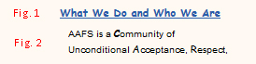

## Identity

As discussed earlier, our identity criterion is based on the marketing channels of communication and transactions. Thus an organization’s website is their online identity; their electronic best foot forward. This section will explore how the AAFS website incorporates the principles of communication and transactions in their website to promote and organize interactions between its current and future members. As stated in Kianga et al (2000), “There is no proven successful method that can help management evaluate how beneficial Internet marketing could be before they commit substantial capital investment on Internet marketing and risk the possibility of interfering with their current channels” (Kianga et al, 2000). As part of this report, we are making these recommendations based upon the assumption that we are providing the lowest risk, highest reward solutions to the potential fallouts of the website’s current usability. However, the successful implementation of a new website is not defined by changing the color scheme, but by bringing AAFS a new level of visibility among the public eye to not only raise awareness and fundraising to their cause, but provide the next level of support to their community. In figure The identity criteria was ranked 2nd highest among the average user experience against our other criteria at 60.19%. The questions related to identity were (positive response % included in brackets):

### Results

* + Q2.1 ) "The website is easily recognized as the Autism Aspergers Friendship Society's website." (73.2%)
  + Q2.6 ) "Information about provided programs is accessible." (73.2%)
  + Q2.7 )"The frequently asked question page is accessible." (69.6%)
  + Q2.8 ) "The content is concise and informative." (73.2%)
  + Q3.6 ) "The graphics of the website enhance the information provided." (32.1%)
  + Q4.0 ) "Was the information under the headers 'What We Believe', 'AAFS Philosophy', and 'Our vision' easy to read in the current column format?" (50%)
  + Q5.0 ) "Is finding the contact information of the Founder and Executive Director of AAFS easy to find?" (50%)

### Discussion

While identity may have been the second highest ranked criteria, when we look at questions 2.1 and 2.6, we see a very large problem. **26.8% of people could not easily recognize AAFS’ website as part of AAFS!** Whereas 26.8% were also unable to access information on AAFS programs or events! It is always important to remember that we are working with a small set of data, and we can then hope that this is an exaggerated percent of people. However, to err on the side of caution, lets assume that approximately twenty five (25) % of all the AAFS website first time visitors do not even know where they are, or what AAFS can do for them. To put it into perspective, that’s roughly one quarter (or one in four) potential donors, future members, or event ticket sales gone just because the information on the website was unable to, or uninteresting enough (only 30 % of participants thought the graphics helped after all), for new visitors to figure out where they are, or what they can do while they’re there.

#### Communication Channel - Member Retention

#### Contact Information

Accessibility to the contact page is a major component to any business or organizations web page. However, the AAFS contact page is broken when users attempt to get to it via the FAQ page. The FAQ page tells users that if they cannot find the answer to their question, to please contact them, however the link used there leads to a 404 error message (fig. 5). According to Stamoulis (2013), “broken links, whether internal or outbound, can hurt the usability of a website” and that 404 error pages lead to a poor user experience. Because accessible contact information is extremely important and also detrimental to website credibility, this is an area of utmost concern.

Aerts (2009) indicates, “good contact information makes you look accessible and that in turn makes people trust you. Looking for contact information is one of the top tasks of many websites”. It is important that contact information is easy to find for users. According to our survey, 64.3% of participants found contact information easy to find. It is vital for users to easily navigate contact information in case of any questions users may have directly for the group. Aerts (2009) suggests, “an item ‘contact’ or ‘contact us’ in the main navigation, best as the last item” or “as a sub-item under ‘about us’”.  The AAFS is already utilizing this suggestion, as seen in figure ?. However, it is also important to note that only 50% of our participants could find the contact information of the founder and executive director, Dean Svoboba. Therefore to accommodate to the users who could not find his information, it should be placed under the ‘contact us’ tab alongside the general information of the AAFS.

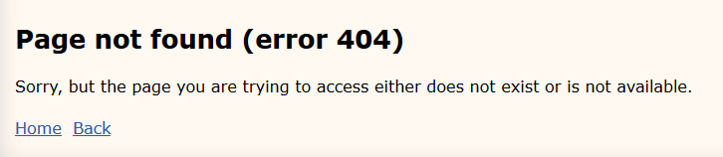

#### Links: Broken, Misleading, and Competing

Links are an important aspect that aid users in moving around on the website and therefore should be easy to find and are easily accessible. Broken links can be detrimental to ensuring easily accessible information from being available.

For example, 10 of 14 participants (71.42%) found that AAFS contact information is easy to find however, they also agreed that the blog link in the ‘contact us’ drop-down should be removed or placed elsewhere as it takes away from the actual contact information page. The placement of the blog under contact information is misleading as some users were directed to the blog and could not find the contact info as they did not realize they had to click on ‘contact us’ versus hover over it.

https://lh3.googleusercontent.com/ry7Mugwo4WB1tmj05Q4SJrWXP-UsW9rpEhGOjLlaXKKCfei0AIMUJ6Ra26cHHHhGU_hVVEVHJnfNBKNJf8GdUohy-MdWx22-GTshqClGRyEBkPwm5u5e4N7DzgX9pJN0zQ

According to Miller (2014), it would be effective to reduce or limit the number of links on the navigation bar as it makes each remaining section more prominent. Having a drop down menu is a concise way to organize navigation links without clogging up the website, making websites more user friendly. Hartstein (2012) explains drop-down menus allow users to scan the different types of content in each section of your website without unnecessarily clicking through the pages of your site”. The National Autistic Society (2014) states, “some people on the spectrum can get 'information overload' very easily”, therefore it would not only appeal to the general public, but also people on the autism spectrum. Less is more because too many navigation buttons leaves users with too many choices, which confuses and frustrates users. According to our survey, 11 out of 14 (78.57%) participants agreed that the navigation tools were user friendly for locating information. This indicates that the existence of the navigation bar in itself is helpful. However, the current drop-down menu is cluttered.

Our survey indicates that 42.9% of participants noted that the links under each drop-down were too cluttered.

# Conclusion

Therefore, because of this interdependence, poor areas of usability often spanned more than one specific criteria; negative user experience is often a culmination of poor coordination between these different criteria

# Recommendations

## Major Recommendations

## Minor Recommendations

# References

# Appendices

## Appendix A: Survey Ethic Foreword

|  |
| --- |
| **Autism Aspergers Friendship Society of Calgary Website Usability Survey** |
|  |
| **Purpose of study:** The goal of the project is to determine and evaluate the usability of The Autism Aspergers Friendship Society of Calgary website. |
|  |
| **Your participation in the study:** Your participation will involve navigating through the aforementioned website for approximately 10 minutes, and filling out a short survey about the accessability of information, the overall aesthetic design, the identity of AAFS as portrayed by its website, and how easy it is to navigate the website. |
|  |
| **Publication of results:** The survey will be used as the basis for analysis by myself, and my partners. It will also be viewed by the instructor, the marker, and potentially other students in the COMS 363 course. Individual survey responses will in no way be made available to the general public. |
|  |
| **Risk to you:** eSurv does not store any personal data such as your name, email, ect. There are no risks associated to this survey. Your participation is entirely voluntary and may be cancelled prior to the end of the survey. Due to the inability to distinguish your responses after submission, any submitted responses may not be removed. |
|  |
| **Informed Consent:** Due to the nature of eSurv, I, or my group members, are unable to identify your survey after you have submitted it and we are unable to remove it. By filling out, and submitting this survey you are consenting to the use of it as part of our study. |
|  |
| **Storage of Materials:** All materials, notes, or comments my group, or our instructors may make will remain confidential. The results of this survey will remain confidential between the group, and its instructors. Any research notes and consent forms will be stored for two years under lock and key, including during the data collection phase. Your survey on eSurv may last up to twelve (12) months after the end of the survey period. |
|  |
| You are free to request more information about the study by contacting any member of our group, or our instructor Lisa Stowe at [lstowe@ucalgary.ca](mailto:lstowe@ucalgary.ca). For additional information on eSurv’s, please refer to their privacy policy. |

## Appendix B: Survey Questions

|  |
| --- |
| 1. Before taking this survey, have you previously visited the AAFS website before, or have had previous involvement with the AAFS? (Check for applicable) |
| |  | | --- | | Yes I have visited the website | | Yes I have been involved with AAFS | | No I have not visited the website |  1. Please answer the following: |
| |  |  |  |  |  |  | | --- | --- | --- | --- | --- | --- | |  | **Strongly Disagree** | **Disagree** | **Neutral** | **Agree** | **Strongly Agree** | | **The website is easily recognized as the Autism Aspergers Friendship Society's website.** |  |  |  |  |  | | **The website layout is user friendly.** |  |  |  |  |  | | **The website layout is easy to follow.** |  |  |  |  |  | | **Navigation tools are user friendly (useful for locating information).** |  |  |  |  |  | | **Contact information is easy to find.** |  |  |  |  |  | | **Information about provided programs is accessible.** |  |  |  |  |  | | **The frequently asked question page is accessible.** |  |  |  |  |  | | **The content is concise and informative.** |  |  |  |  |  | | **The content of the website was formatted in a well-organized manner.** |  |  |  |  |  | | **There are no broken links.** |  |  |  |  |  | |
| 1. Please answer the following questions regarding website aesthetics. |
| |  |  |  |  |  |  | | --- | --- | --- | --- | --- | --- | |  | **Strongly Disagree** | **Disagree** | **Neutral** | **Agree** | **Strongly Agree** | | **This website is visually appealing.** |  |  |  |  |  | | **The color scheme is appealing.** |  |  |  |  |  | | **The choice of font is appropriate.** |  |  |  |  |  | | **The choice of font size is appropriate.** |  |  |  |  |  | | **The graphics of the website are visually appealing.** |  |  |  |  |  | | **The graphics of the website enhance the information provided.** |  |  |  |  |  | |
| 1. On the AAFS homepage (http://www.aafscalgary.com) was the information under the headers 'What We Believe', 'AAFS Philosophy', and 'Our vision': |
|  |
|  |
|  |

## Appendix B: Survey Questions cont…

|  |  |  |  |
| --- | --- | --- | --- |
| |  | | --- | | Easy to read in the current column format. | |  | | Difficult to read in the current column format. |  1. Is finding the contact information of the Founder and Executive Director of AAFS easy to find? |
| |  | | --- | | Yes | | No |  1. Looking at the navigation bar, do you think the links in the menu under each drop-down too cluttered: |
| |  | | --- | | Yes | | No | |

## Appendix C: Survey Results

## Appendix D: W3C Accessibility Guidelines

| Guide line # | Guideline | Short Description |
| --- | --- | --- |
| 1 | Provide equivalent alternatives to auditory and visual content. | Provide content that, when presented to the user, conveys essentially the same function or purpose as auditory or visual content. |
| 2 | Don't rely on color alone. | Ensure that text and graphics are understandable when viewed without color. |
| 3 | Use markup and style sheets and do so properly. | Mark up documents with the proper structural elements. Control presentation with style sheets rather than with presentation elements and attributes. |
| 4 | Clarify natural language usage | Use markup that facilitates pronunciation or interpretation of abbreviated or foreign text. |
| 5 | Create tables that transform gracefully. | Ensure that tables have necessary markup to be transformed by accessible browsers and other user agents. |
| 6 | Ensure that pages featuring new technologies transform gracefully. | Ensure that pages are accessible even when newer technologies are not supported or are turned off. |
| 7 | Ensure user control of time-sensitive content changes. | Ensure that moving, blinking, scrolling, or auto-updating objects or pages may be paused or stopped. |
| 8 | Ensure direct accessibility of embedded user interfaces. | Ensure that the user interface follows principles of accessible design: device-independent access to functionality, keyboard operability, self-voicing, etc. |
| 9 | Design for device-independence. | Use features that enable activation of page elements via a variety of input devices. |
| 10 | Use interim solutions. | Use interim accessibility solutions so that assistive technologies and older browsers will operate correctly. |
| 11 | Use W3C technologies and guidelines. | Use W3C technologies (according to specification) and follow accessibility guidelines. |
| 12 | Provide context and orientation information. | Provide context and orientation information to help users understand complex pages or elements. |
| 13 | Provide clear navigation mechanisms. | Provide clear and consistent navigation mechanisms -- orientation information, navigation bars, a site map, etc. -- to increase the likelihood that a person will find what they are looking for at a site. |
| 14 | Ensure that documents are clear and simple. | Ensure that documents are clear and simple so they may be more easily understood. |